Authors :
- Ronan Le Boulch

Getting Started with Cdash & Pipol

Summary :
Read this document to learn how to start testing MPTK with Cdash and Pipol servers

LAYOUT
1.Introduction 3
1.1.What is Cdash ? 3
1.2.What is PIPOL ? 3
1.3.Description of the working process 4
2.How to subscribe to PIPOL 5
3.How to install libraries for the host machine 6
4.How to manually use a remote host 7
4.1.Booking a node 7
4.2.Connecting to a node 8
4.3.Using the node 8
5.How to automatically use a remote host 9
5.1.Configuring the nightly script 9
5.2.Modifying the nightly script 9

- Introduction

What is Cdash ?
Quoting from Wikipedia, “CDash is an open source, web-based software testing server. CDash aggregates, analyzes and displays the results of software testing processes submitted from clients located around the world. Developers depend on CDash to convey the state of a software system, and to continually improve its quality. CDash is a part of a larger software process that integrates Kitware's CMake, CTest, and CPack tools, as well as other external packages used to design, manage and maintain large-scale software system”.

For its software development, INRIA has setup a Cdash server accessible at cdash.inria/fr.
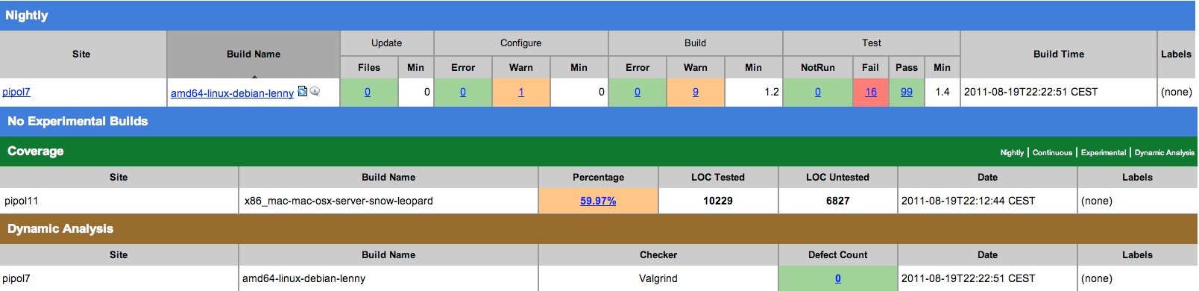Illustration 1: Example of a bunch of tests executed on a Debian lenny Linux (99 pass / 16 fail)
Each build submitted by a site corresponds to a row in the main dashboard. By default the build falls in the group defined by the type of submission (i.e Nightly, Experimental or Continuous), however, custom builds can be defined.

What is PIPOL ?
The PIPOL platform is a porting, testing and compilation cluster setup by INRIA for its software development. It hosts several hardware and software architectures to perform its work. An user can reserve a resource (a specific hardware, an operating system...) to be used interactively or automatically (with a "Nightly Builds" system) for software testing. PIPOL allows the users to realize their tasks through several OS and architectures.
It includes several different tasks such as :
    - The customization to new architectures, systems, distributions and versions
- The compilation | - The automatics/manual tests
- The coverage of the code | - The dynamic analysis
- The packaging | - The reproduction of bugs
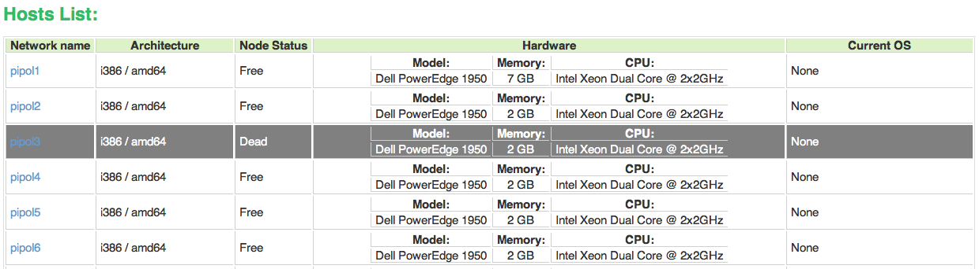

Description of the working process
Here is how Cdash and Pipol are connected in order to, either manually, or automatically, launch some tests and retrieve the results :
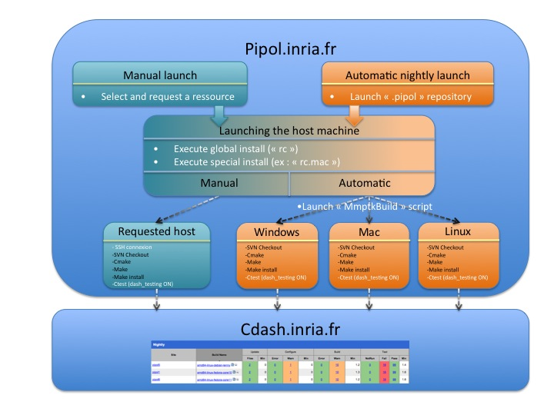
The following will describe the basic principles about how to use Cdash website and/or the PIPOL servers depending on the user wishes. It is divided into four major sections :

- How can I subscribe to PIPOL ?
- How can I manually test MPTK ?
- How can I automatically test MPTK ?
  - What is this “.pipol” repository ?
  - How can I automatically install libraries ?
  - How can I add a new host machine into the automatic test ?
  - How can I submit the changes of the nightly scripts ?
  - How can I automatically test my submitted code ?
- How to subscribe to PIPOL
In order to obtain an account on the portage platform, you need to connect onto PIPOL interface (http://pipol.inria.fr), then to select the link “Account request” or to go directly at this adress : http://pipol.inria.fr/users/

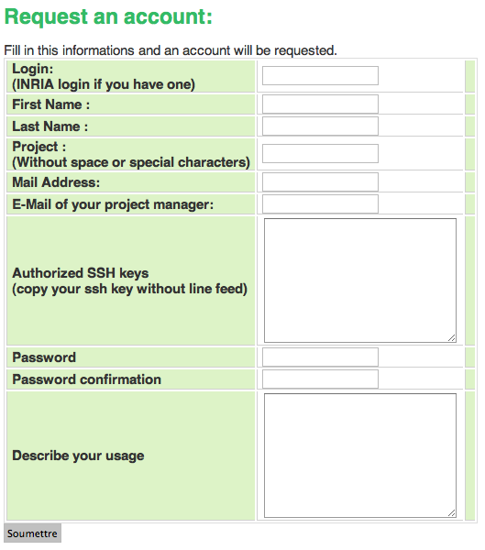
Make sure to fill correctly the asked informations which will be used to create your user account, allowing you to connect to the different nodes of the platform. In the field “SSH authorized keys”, you will have to copy/paste your SSH public key (id_rsa.pub, id_dsa.pub ...). This field is really important. Thanks to this information you will be able to access the platform.

Once your request is submitted you will receive two e-mails : The first one will warn you that your account request will be transferred to the administrators for validation, and the second one when your account will be activated.
- How to manually use a remote host

If you have an account on the pipol platform and you want to manually open a portage session, here are the different step to follow.
A good tutorial is available under the pipol website (http://pipol.inria.fr)

Booking a node
First of all, when logged in, you must book a node on the platform corresponding to the material architecture you want to use.

- Select the host you want to connect in and reserve this node
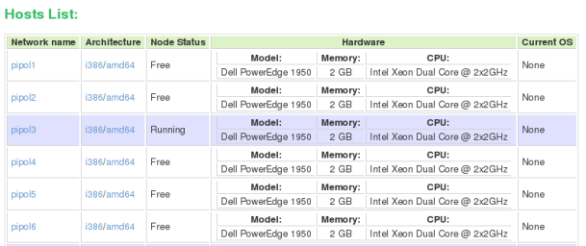
- You can either select a duration or a schedule reservation
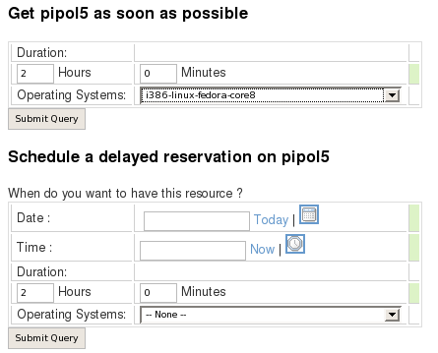
- When submitting, you just have to wait for the machine to be mounted and you will receive an e-mail. It can take about 10 to 40 minutes depending on how much packages you want to install on this machine.
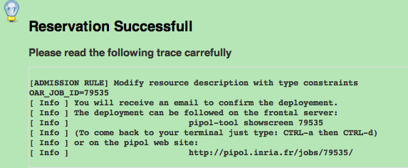

Connecting to a node
When the reservation of a node is successful, here is an example of the mail you should receive :
The OS :

amd64-linux-fedora-core13.dd.gz is now deployed on node pipol3.

Connection as simple user :
$ ssh YourLogin@pipol3.inrialpes.fr

Connection as root :
$ ssh root@pipol3.inrialpes.fr

Contact:
pipol-sysadm@lists.gforge.inria.fr

PIPOL ADMINISTRATORS

Windows Issue :
When using Windows, the manual connexion to a host machine doesn't give the same rights than a nightly connexion. That's why a procedure needs to be followed in order to make everything works properly. Those steps are described on the terminal when a user connects to the host machine however there are several changes to operate.

When the user is connected to the host machine :
→ Change root password with the command:
$ net user root newpassword
→ Logout the Cygwin Shell:
$ exit
→ Connect again with the following command:
$ ssh -o PubKeyAuthentication=no -o PasswordAuthentication=yes root@pipol3.inrialpes.fr
→ Then the Microsoft Compilers will work fine with Cygwin shell.
If you don't have access to the netshare directory in: /netshare
→ Just type the commands:
$ net use y: '\\194.199.16.193\netshare' /USER:YourLogin password
$ ln -s /cygdrive/y /netshare

Using the node
Once you're connected to the deployed machine, the next step is to retrieve the MPTK distribution. Then you will be able to install the needed libraries (see chapter 3.4), compile, execute and test your code.
The easiest way to dowload MPTK is to do a checkout through svn :

svn checkout svn+ssh://YourLogin@scm.gforge.inria.fr/svn/mptk/trunk MPTK_Source

This syntax retrieves the svn trunk files and insert it into a repository named “MPTK_Source”. You can use the test execution script file situated under the “MPTK_Source /.pipol/Experimental” directory as an example or directly launch it to execute the test sequence.

Installing libraries from the PIPOL “cloud”
When the node has been manually launched, the image mounted is a basic one. Nevertheless, MPTK needs few specific libraries, such as “sndfile”, “fftw3”, and “Cmake” to work properly. You can either install it manually, or use the scripts that are made for automatic tests :
- Launch the general rc “MPTK_Source/.pipol/rc” to install Cmake on the remote host
- Launch one of those specific rc :
  - “MPTK_Source/.pipol/rc.mac” to install “sndfile” and “fftw3” on a mac
  - “MPTK_Source/.pipol/rc.fedora” to install “sndfile” and “fftw3” on a fedora
  - ...
- How to automatically use a remote host

What is the .pipol repository
The principle of automatic tests is pretty simple. Each night, PIPOL executes :
- Any executable script situated under “$HOME/.pipol/nightly”
- For each mounted machine, PIPOL executes the “rc's” situated under “$HOME/.pipol :
  - The general Run Command (“rc”)
  - The specific Run Command (“rc.mac”, “rc.linux”...) depending on the architecture

PIPOL is also able to parse arguments and to execute special commands from an executable script under the condition that it includes special commentary lines :

#PIPOL <arguments that pipol understands>

You can find more informations under the PIPOL website : http://pipol/docs/user/user-manual.html. The following example is requesting PIPOL to mount any machine image containing the sentence “i386-linux-fedora” for 4 hours.

#!/bin/bash
#PIPOL i386-linux-fedora 4:00

The result will consist into mounting all of these hosts available under PIPOL :

i386-linux-fedora-core7.dd.gz | i386-linux-fedora-core8.dd.gz | i386-linux-fedora-core9.dd.gz | i386-linux-fedora-core10.dd.gz
i386-linux-fedora-core11.dd.gz | i386-linux-fedora-core12.dd.gz | i386-linux-fedora-core13.dd.gz

How can I add a new host machine
If you read the paragraph 4.1, you can easily understand how to add a new host machine into the automatic nightly test :
- Open the nightly script that you want to modify
- Add a new line in order to add, for example, the “amd64-linux-fedora” machines

#!/bin/bash
#PIPOL i386-linux-fedora 4:00
#PIPOL amd64-linux-fedora 4:00

This will have for consequence to mount all of these hosts available under PIPOL :

i386-linux-fedora-core7.dd.gz | i386-linux-fedora-core8.dd.gz | i386-linux-fedora-core9.dd.gz | i386-linux-fedora-core10.dd.gz
i386-linux-fedora-core11.dd.gz | i386-linux-fedora-core12.dd.gz | i386-linux-fedora-core13.dd.gz | amd64-linux-fedora-core7.dd.gz
amd64-linux-fedora-core8.dd.gz | amd64-linux-fedora-core9.dd.gz | amd64-linux-fedora-core10.dd.gz | amd64-linux-fedora-core11.dd.gz
amd64-linux-fedora-core12.dd.gz | amd64-linux-fedora-core13.dd.gz

How to automatically install libraries
When you decide to mount a remote machine, some files are launched on the remote host. The principle is to avoid a serie of manual operations after each deployment. This automatic configuration is planned from initialisation commands named “Run Command” (rc) that the user can insert under the repository $HOME/.pipol

There are two types of rc :
- A primary rc ($HOME/.pipol/rc) which is executed on all the systems
- Some secondary rc ($HOME/.pipol/rc.<part>) for which the executions depend on the architecture of the host machine.

General rc to install Cmake (rc) | Mac rc (rc.mac)
#!/bin/bash  ##########################################################  ## Get required version of cmake (required for cpack)  ##########################################################  case $PIPOL_IMAGE in  *fedora*)  yum -y -qq install wget  ;;  *);;  esac  case $PIPOL_IMAGE in  *debian-etch*|*ubuntu-feisty*) cmake_version=2.6.4;;  *) cmake_version=2.8.5-rc1;;  esac  if [ "`cmake --version`" != "cmake version ${cmake_version}" ]; then  echo "Cmake n'existe pas ou sa version n'est pas ${cmake_version}..."  echo "Installation de cmake..."  wget http://www.cmake.org/files/v2.8/cmake-${cmake_version}.tar.gz  gunzip cmake-${cmake_version}.tar.gz  tar xvf cmake-${cmake_version}.tar  cd cmake-${cmake_version}; {  ./bootstrap  case $PIPOL_IMAGE in  *mac*) ./configure --prefix=/opt/local;;  *);;  esac  make  sudo make install  date  }; cd -  rm -r cmake-${cmake_version}  rm cmake-${cmake_version}.tar  fi | #!/bin/bash  ##########################################################  ## MPTK dependencies  ##########################################################  echo "---------------------------------------------------"  echo "Installation de la librairie libsndfile..."  echo "---------------------------------------------------"  apt-get install -y -qq libsndfile1-dev  echo "---------------------------------------------------"  echo "Installation de la librairie fftw3..."  echo "---------------------------------------------------"  apt-get install -y -qq libfftw3-dev  echo "---------------------------------------------------"  echo "Installation de la librairie rpm..."  echo "---------------------------------------------------"  apt-get install -y -qq rpm

How can I submit changes of the nightly scripts
BE CAREFUL : Modifying and submitting with SVN the MPTK nightly scripts doesn't mean that PIPOL has taken in account those modifications.

You must differenciate :
- Which folder does PIPOL use to launch my nightly scripts (“$HOME/.pipol/nightly”)
- Where does my modified scripts are after a checkout (“MPTK_Source/.pipol/nightly”)
So after a modification of a nightly script and a submission on SVN, copy the whole directory “nightly” situated under “MPTK_Source/.pipol”, to the “$HOME/.pipol” directory. Then, the server will execute this script each night.

How can I test my submitted code
If you read the paragraphs 4.1 and 4.2, you can easily understand that PIPOL will always execute the executable scripts available under the directory “$HOME/.pipol/nightly”.

Fortunately, MPTK script named “MptkBuild” includes a line with a SVN checkout :

svn checkout svn+ssh://YourLogin@scm.gforge.inria.fr/svn/mptk/trunk MPTK_Source

This line means that as long as PIPOL will perform tests, it will always test the SUBMITTED “trunk” part of MPTK.

